**Maven Configuration and Guide**

🡪 First install Java and Maven

🡪 Launch instance, run the commands,

**sudo su**

**yum update -y**



**yum install java-17 -y**



**yum install maven -y**



🡪 to check version

**mvn –version**

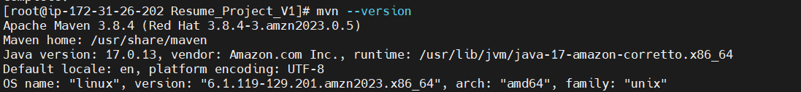

**To Run a Project,**

* Download project from git Repo

**yum install git -y**



**mkdir Project name**



**cd** Project Name



**git init**



**git pull repo link url**



* Hear download all project to git repo, now have to generate pom.xml file, in this file have all package detail
* to generate archetype:generate

**mvn archetype:generate**



have to give archetype ex: **2209**



have to give version ex: **9**

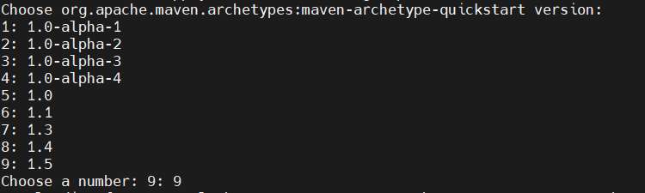

have to give group Id ex: **com.resumev1**

have to give artifactid ex: **myprofile**

have to give snapshot version ex: **0.0.1-snapshot**

have to give package value ex: **war or jar**

have to give yes or no ex: **Y**

Build Success

🡪 it will create directory inside myprofile

🡪 inside pom.xml file available, and src inside main and test file available

* main inside package application available java or web app it will display

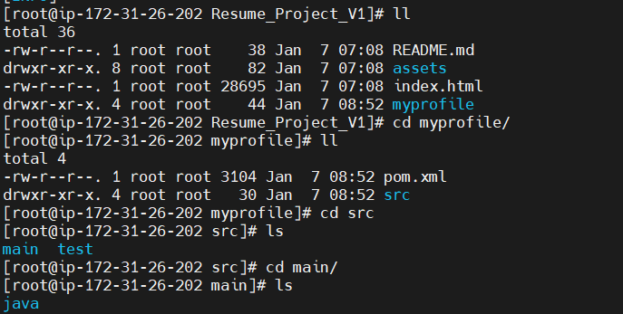

🡪 now need to move pom.xml file outside myprofile

* it should move on Resume_Project_V1

**mv /home/ec2-user/Resume_Project_V1/myprofile/pom.xml /home/ec2-user/Resume_Project_V1**



**cat pom.xml –** able to read a file



🡪 to build the Package

**mvn clean package**



**Clean Package build Success**

* it will generate target file

**cd target**



🡪 inside package created

🡪 want to see hole package in tree structure

**yum install tree**



Final Output

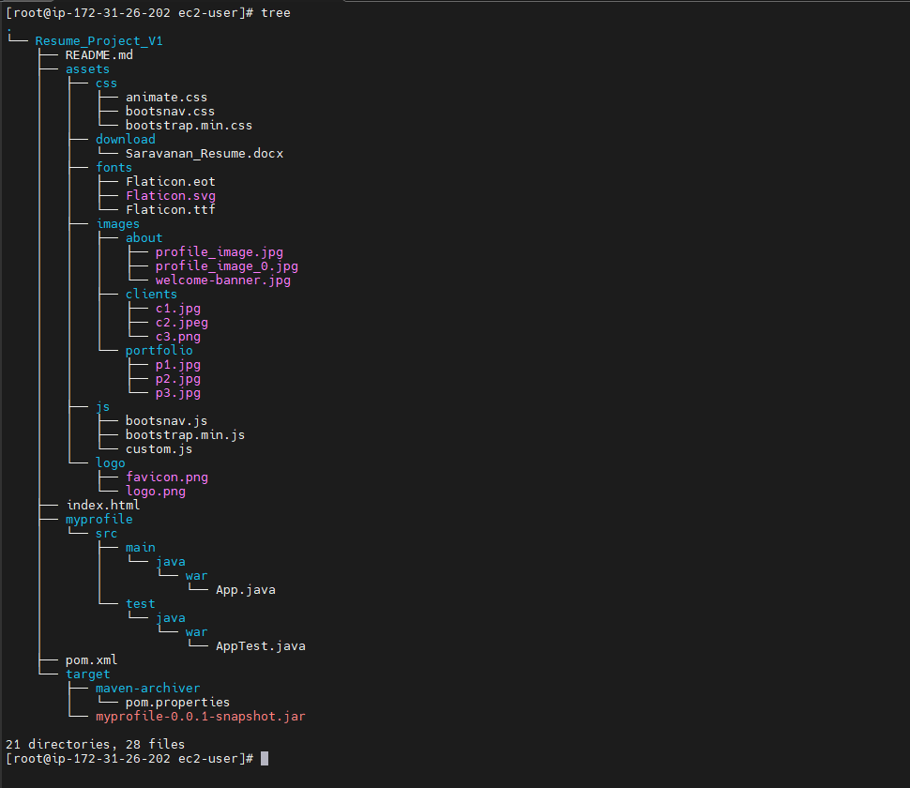

The pom. xml file is an XML file that contains information about the project and configuration details used by Maven to manage the project's build, documentation, reporting, and dependencies.

Maven is a DevOps tool that automates the process of building, managing, and deploying applications:

* **Project management**

Maven helps manage projects by simplifying and standardizing the building process.

* **Documentation**

Maven automatically generates project documentation, including details on the project's structure, dependencies, and configurations.

* **Reporting**

Maven produces detailed reports on various project aspects like code quality, test coverage, and build statistics.